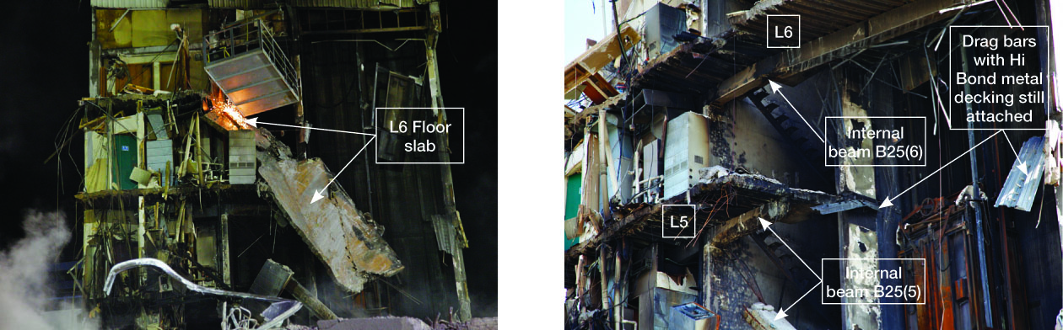

(a) Detachment of floors at levels 4, 5 and 6 (b) Level 5 and 6 floor slab, drag bar and beam connection

Figure 67: Floor slab connection to north wall complex (source: Robert Heywood)

5.1.3.6 Western wall

A block wall was constructed on the first three levels of the western side of the building. The wall provided resistance to fire from the adjacent building and was not designed to contribute to the lateral load resistance of the CTV building. Dr Heywood observed sealant on the side of some rectangular columns in a position consistent with the 140mm block work (Figure 68). There was no sign of ties or reinforcement connecting the rectangular column and the block work. This evidence suggests that the wall was constructed as detailed in the structural drawings.

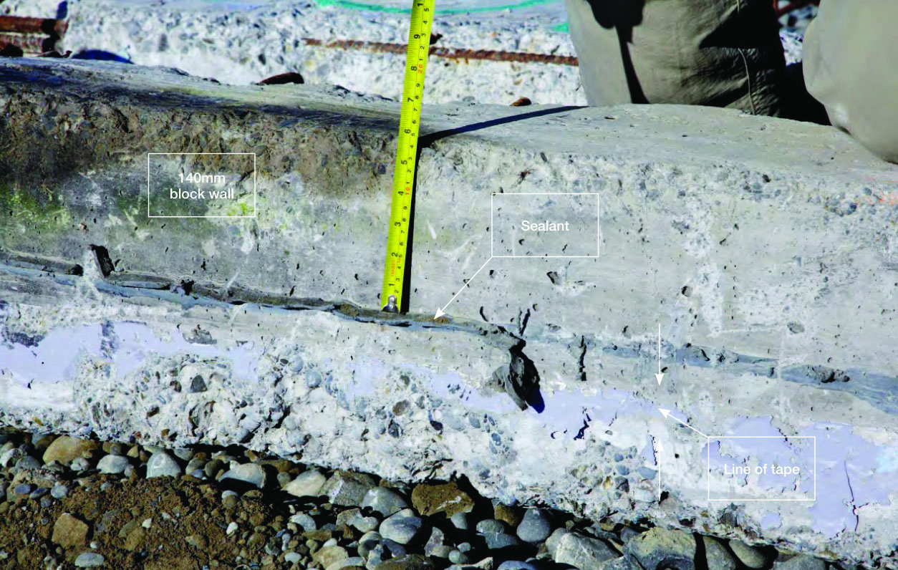

Figure 68: Sealant on a remnant of the western wall (source: Robert Heywood)

5.1.3.7 South shear wall

Mr Frost observed some horizontal cracking and spalling near the base of the south shear wall. He described this cracking as consistent with weak axis bending (bending to the north). These cracks were widest at the outer face (see Figure 69(b)) and barely visible on the inside face. Mr Frost saw no evidence of vertical movement of this wall relative to the adjacent ground slab.

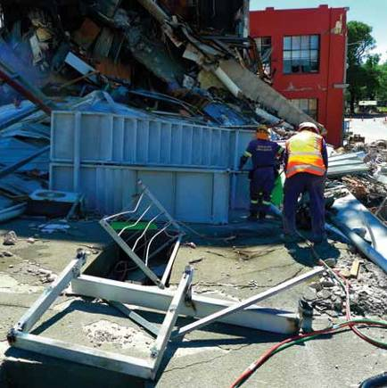Mr Frost had expected to see a significant amount of diagonal cracking in the coupling beams located above the doorway openings in the south shear wall. However, he saw no sign of such cracking. He concluded that the south shear wall had experienced little or no horizontal loading. Dr Heywood drew attention to Figure 69(a), which is a photograph taken on top of the south shear wall around level 3. He noted that the cracking in the south shear wall appeared to be more severe on the eastern side.

South shear wall showing cracking on eastern side

Figure 69(a): Upper levels of south shear wall shown in the foreground lying flat in a photograph taken on top of building debris (source: Graham Frost)

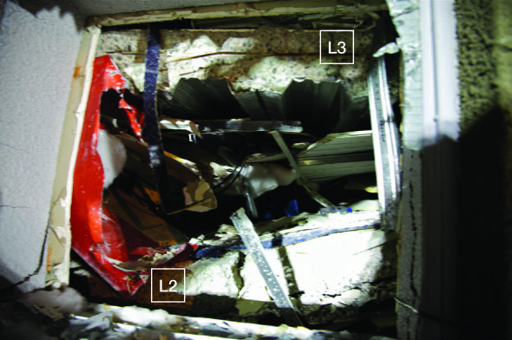
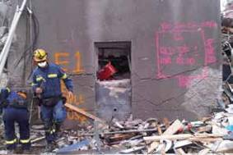

(b) Level 1 of the south shear wall (source: Graham Frost)
(c) Floor slab through level 1 door window
(source: Robert Heywood)

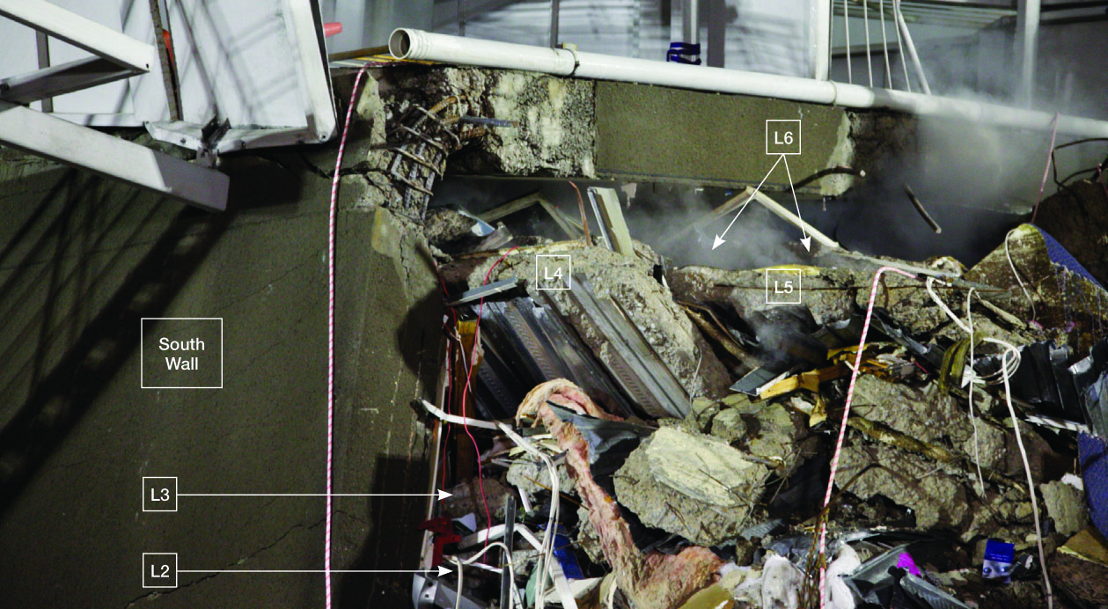

(d) Eastern side of collapsed south shear wall with floor slabs below (source: Robert Heywood)

Figure 69: South shear wall

Figure 69(c) is a view taken through the broken window, which can be seen in Figure 69(b). Dr Heywood identified the severed edges of the level 2 and 3 floor slabs through this window. Figure 69(d) is a view of the edges of the floor slabs visible to the east of the south shear wall. Dr Heywood identified all five suspended floor slabs in this area. The connections between each of the suspended floor slabs and the south shear wall were severed and the edges of the floor came to rest relatively close to the base of the south shear wall. This indicated floor detachment before the south shear wall collapsed.

5.1.3.8 North wall complex

Dr Heywood observed portions of the north wall complex in good condition (see Figure 70(a)), except where damage had resulted from the edge beams pulling away from the walls. A closer inspection of the northern face revealed two horizontal cracks in the rendered concrete within a metre of ground level (Figure 70(b)). Dr Heywood suggested this cracking could have been either pre-existing or caused by bending towards the south. He thought that the north wall complex performed well during the earthquake.
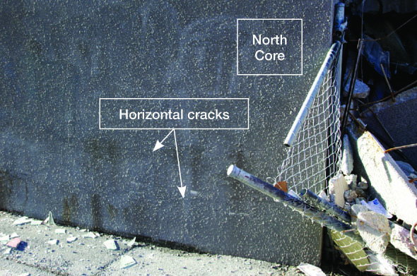

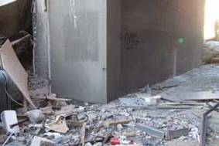(a) Eastern elevation of wall complex (source: Graham Frost) (b) Cracking in northern face, western end
(source: Robert Heywood)
Figure 70: Damage to north wall complex

5.1.3.9 Concrete

The USAR engineers were concerned about both the compression and tension strength of the concrete. Dr Heywood said its propensity to disintegrate into rubble made it surprisingly difficult to lift any substantial piece of concrete without it breaking into pieces. Reinforcement could be pulled from the concrete, which indicated poor anchorage.

Tests were conducted to determine concrete strength and these are discussed in section 2.3.4.

5.1.4 Forensic engineering practice practice

The Royal Commission heard expert evidence from Professor Robin Shepherd about forensic engineering aspects of the CTV building investigation. Professor Shepherd, who was called as a witness by ARCL and Dr Reay, is an Emeritus Professor at the University of California, Irvine and a consulting engineer. He stated that various efforts have been made, most notably in the United States, to standardise best-practice for structural failure investigations.
Professor Shepherd recommended that a more formal process, including chain of custody records, should be required for structural collapse inquiries in New Zealand, particularly where loss of life occurs. His view was that better organised handling of the physical evidence resulting from the CTV building collapse would have greatly facilitated subsequent inquiry. In his view, there was “wholesale destruction of evidence” in the clearance of the CTV site. He claimed there were some key omissions that would make the Royal Commission’s job much harder, in particular that there was no chain of custody and no information about the exact location of where columns and reinforcing had come from.

Professor Shepherd accepted that the priority following collapse was the rescue of survivors and then recovery of bodies. Due to the almost total collapse of the building, essentially all the remnants had to be moved. Professor Shepherd stated that building remnants should not have been destroyed. He had not visited the Burwood landfill, although he had seen photographs. He said that he not reviewed the evidence of Mr Frost, Dr Heywood and Mr Trowsdale. He acknowledged his opinion was partly based on newspaper reports.

The public-spirited initiative by Mr Frost, Dr Heywood and Mr Trowsdale created an excellent record of the state of the building and individual elements following collapse. There was no formal system whereby this information was collected and the Royal Commission commends these engineers for their very thorough documentation and assessment of the collapse debris.

Counsel assisting accepted that criticisms of the failure to preserve the scene can be validly made. For example, the removal of the south shear wall and north wall complex debris was a premature decision, as all affected parties could not properly examine the debris. Counsel for ARCL and Dr Reay submitted that the Royal Commission investigation was under- informed in important respects and endorsed the suggestion of counsel assisting that guidelines about best-practice for structural failure investigations, such as those formulated in the United States by the National Academy of Forensic Engineers (NAFE) and the American Society of Civil Engineers’ Technical Council of Forensic Engineers (TCFE), as referred to by Professor Shepherd, would be of assistance in New Zealand and should be investigated by the Ministry of Business, Innovation and Employment.

Despite these submissions, we consider that the combination of the evidence of Mr Frost, Dr Heywood and Mr Trowsdale, together with other expert observations and the eye witness accounts, provides a reasonable and proper forensic basis for consideration of the relevant issues the Royal Commission has to address.

Overall, we consider that the evidence provides an adequate basis to make findings about the state of the building and to draw conclusions about possible collapse scenarios. However, implementation of guidelines for forensic engineering is warranted to ensure that high quality forensic work is guaranteed for future investigations.

Recommendation

We recommend that:

108. The Ministry of Business, Innovation and Employment should consider developing guidelines for structural failure investigations, including circumstances in which sites should be preserved for formal forensic examination.

5.2 Technical investigations by the former Department of Building
and Housing

5.2.1 Introduction

After the February earthquake the former Department of Building and Housing (DBH) began a technical investigation to look at the performance of four relatively modern multi-storey buildings in the CBD that suffered serious structural failures. These investigations included the CTV building, the PGC building, the Forsyth Barr building and the Hotel Grand Chancellor. The other three buildings, and the DBH investigations into their failures, were addressed by the Royal Commission in Volume 2 of our Report.

The DBH investigation of the CTV building used records of building design, examination of building debris, photographs, video recordings, computer analyses and first-hand accounts of the state and performance of the building before and during the February 2011 earthquake. The investigation and report was to establish, where possible, the cause or causes of building failure. It was not intended to address issues of culpability or liability arising from the collapse of the building.

The Department appointed Dr Clark Hyland of Hyland Consultants Ltd (HCL), and Mr Ashley Smith of StructureSmith Ltd (SSL), to investigate the CTV building. It also established an Expert Panel to oversee their work, provide guidance on the methodology of the investigations and peer review the findings.

5.2.2 The Hyland/Smith investigation

The findings of the Hyland/Smith investigation were presented to the Royal Commission by Dr Hyland and Mr Smith, co-authors of the Hyland/Smith1 report. Dr Hyland2 also prepared a separate report dated 16 January 2012 for DBH entitled, “CTV Building Site Examinations and Materials Tests”. Mr Smith was responsible for coordinating non-linear seismic analysis for the Hyland/Smith report. Compusoft Engineering assisted with computer analyses and Tonkin & Taylor with the geotechnical engineering aspects.

The conclusions of the Hyland/Smith report were summarised in section 10 of that report as follows:

The investigation has shown that the CTV Building collapsed because earthquake shaking generated forces and displacements in a critical column (or columns) sufficient to cause failure. Once one column failed, other columns rapidly became overloaded and failed.

The investigation found no evidence to indicate that the damage to the structure observed and/or reported after the September Earthquake and the December Aftershock had caused any significant weakening of the structure with respect to the mode of collapse in the February Aftershock.

Although there is some scope for interpretation of the reported building condition, the estimated response of the building using the September Earthquake ground shaking records and the assessed effects on critical elements are not inconsistent with observations following the September Earthquake. The analyses and observations were found not to be very sensitive to the level of demand assumed. The results and conclusions would remain largely unchanged at a lower level of demand in September and February.

Analyses using the full February Aftershock ground motion records indicate drift demands on critical column elements to have been in excess of their capacities even assuming no spandrel interaction and no vertical earthquake accelerations.
The following factors were identified as likely or possible contributors to the collapse of the CTV Building:

• The stronger than design-level ground shaking.

• The low displacement-drift capacity of the
columns due to:

– The low amounts of spiral reinforcing in the columns which resulted in sudden failure once concrete strain limits were reached.
– The large proportion of cover concrete, which would have substantially reduced the capacity of columns after crushing and spalling.
– Significantly lower than expected concrete strength in some of the critical columns.
– The effects of vertical earthquake accelerations, probably increasing the axial load demand on the columns and reducing their capacity to sustain drift.

• The lack of sufficient separation between the perimeter columns and the Spandrel Panels which may have reduced the capacity of the columns to sustain the lateral building displacements.

• The plan irregularity of the earthquake-resisting elements which further increased the inter- storey drifts on the east and south faces.

• Increased displacement demands due to
diaphragm (slab) separation from the North Core.

• The plan and vertical irregularity produced by the influence of the masonry walls on the west face up to Level 4 which further amplified the torsional response and displacement demand.

• The limited robustness (tying together of the building) and redundancy (alternative load path) which meant that the collapse was rapid and extensive.
Surveys of the site after the collapse indicated that there had been no significant vertical or horizontal movement of the foundations. There was no evidence of liquefaction.

Mr Smith said at the hearing that, after considering information that became available after the report was completed, he still agreed in general terms with the conclusions of the report. He did, however, consider that he would now change the emphasis on some of the conclusions. He accepted that beam-column joint failure was a possible mode of failure that was not specifically mentioned in the conclusions, and his opinion was that it should have been included.

Dr Hyland and Mr Smith made some recommendations in section 11 of their report:

The performance of the CTV Building during the
22 February 2011 aftershock has highlighted the potential vulnerability in large earthquakes of the following:

Irregular Structures

Geometrically irregular structures may not perform as well as structural analyses indicate. There is a need to review the way in which structural irregularities are dealt with in design standards and methods.

Non-ductile Columns

Buildings designed before NZS 3101:1995, and especially those designed prior to NZS 4203:1992 (which increased the design drift demand), with non-ductile gravity columns may be unacceptably vulnerable. They should be checked and a retrospective retrofit programme considered.

Pre-cast Concrete Panels and Masonry Infill Walls

Existing buildings with part-height pre-cast concrete panels (or similar elements) between columns may be at risk if separation gaps are not sufficient and maintained. Such buildings should be identified and remedial action taken.

Diaphragm Connections

Buildings with connections between floor slabs and shear walls (diaphragm connections) designed to the provisions of Loadings Standard NZ 4203 prior to 1992 may be at risk. Further investigation into the design of connections between floor slabs and structural walls is needed.
Design and Construction Quality

There is a need for improved confidence in design and construction quality. Measures need to be implemented which achieve this. Design and Construction Features Reports should be introduced and made mandatory. Designers must have an appropriate level of involvement in construction monitoring. There should be a focus on concrete mix designs, in-situ concrete test strengths, construction joint preparation and seismic gap achievement.

It is recommended that the Department (this was a reference to the former Department of Building and Housing) take action to address these concerns as a matter of priority and importance. The first four recommendations identify characteristics that, individually and collectively, could have a serious effect on the structural performance of a significant number of existing buildings. It is suggested that these issues be addressed collectively rather than individually.

The authors recommend that the Department leads a review of the issues raised around design and construction quality. The Department should work with industry to develop and implement changes to relevant legislation, regulations, standards and practices to effect necessary improvements.

5.2.3 DBH Expert Panel report

In addition to appointing Dr Hyland and Mr Smith
to investigate and report, DBH appointed an Expert Panel to oversee their work and review and approve their report. The Chair of the Expert Panel was Mr Sherwyn Williams, a specialist in the field of construction law. The Deputy Chair was Professor Nigel Priestley, an internationally renowned expert on the seismic design of buildings. Other members were Dr Hyland, Mr Rob Jury of Beca, Professor Stefano Pampanin from the Department of Civil and Natural Resources at the University of Canterbury and Mr Adam Thornton of Dunning Thornton, all of whom have expertise in the design of buildings. In addition, Dr Helen Anderson, Mr Marshall Cook, Mr Peter Fehl, Mr Peter Millar and Mr George Skimming contributed expertise respectively in seismology, architecture, construction, geotechnical practice and the role of territorial authorities in regulating building work.

The findings of the Expert Panel report were presented to the Royal Commission by Mr Jury. In section 5.13 of their report3 the Expert Panel endorsed the conclusions in the Hyland/Smith report. The Panel added “loss of diaphragm connection to the [north wall complex] at Lines D and E” as a further possible contributor to the collapse of the CTV building.

The Panel also endorsed in section 5.14 of their report the Hyland/Smith recommendations.

5.3 Technical investigations instigated by the Royal Commission

The Royal Commission retained experts and directed expert panels to convene on specific topic areas.

These investigations were as follows:

• Mr William T. Holmes was engaged to carry out
a peer review of the Hyland/Smith report and the
DBH Expert Panel report;

• Dr James Mackechnie was asked to carry out a review of the concrete testing and its interpretation in the Hyland/Smith report;

• Holmes Solutions Limited was asked to test remnants of reinforcing steel extracted from the CTV rubble stored at Burwood to determine the possible effects of strain ageing on those specimens; and

• expert witnesses were directed to confer about issues relating to non-linear time history and elastic response spectra analyses of the building. To support these experts, we engaged Compusoft Engineering Limited (Compusoft) to carry out further modal and non-linear analyses.

5.3.1 Mr William T. Holmes

The Royal Commission retained Mr Holmes of Rutherford and Chekene in California to review both the Hyland/Smith report and the Expert Panel report. Mr Holmes is an acknowledged authority in the seismic design of buildings. Mr Holmes provided a written review4, which he amplified at the hearing. In addition, the Royal Commission retained him to investigate and advise whether the penetration made in the level 2 floor diaphragm in 2000 could have had any effect on the seismic performance of the CTV building.

5.3.1.1 Review of the Hyland/Smith and Expert
Panel reports

Mr Holmes summarised his conclusions about the Hyland/Smith and DBH reports and his recommendations. These were presented in a slide show at the hearing and are as follows:

Conclusions

The exact set of deformations that instigated the collapse will never be known, even with more extensive modelling, due to contributions that can only be estimated.

• Exact ground motion demand:

• Drifts at which joints would degrade

• Strength and stiffness of diaphragm and its
connection to the tower

• The extent of interaction of the block wall on
line A.

• The effect of vertical ground motions on critical
components.

Judgment indicates that brittle gravity frames and poor diaphragm and connections were most significant.

Lessons learned

1. Brittle gravity frames

(a) It appears that for this building, if NZS 3101:1982, paragraph 3.5.14 was checked, the solution would have resulted in a requirement to apply the requirements of only Chapter 14 Limited Ductility. I have not evaluated the gravity system that would have resulted from such an application, and, in fact, the detail of the requirements may be open to interpretation. I recommend that designs of this era be reviewed to see if this requirement would commonly be triggered, and if so, whether the resulting deformation limits would be adequate.
(b) The configuration of the beam-column joints in this building are primarily a result of the use of pre-cast shell beams and starter beams. The use of pre-cast in this way in this era may also be cause to require review of drawings.
2. Diaphragm issues

(c) Potential issues with the use of relatively thin toppings with mesh reinforcing have been highlighted in several buildings.
(d) The lack of collectors to the north tower has been discussed at length. It is unclear if this design was common at the time and something that needs systematic checking. However, I believe several other buildings of different eras have been discovered in Christchurch that have incomplete diaphragm designs or lack of Collectors. The state of the practice over the last 25 years in this regard should be established to better direct the investigation of older buildings.
(e) The adequacy of diaphragm design forces should also be reviewed.
3. Interaction of “non-structural” walls or other elements.

(f) The construction details of the block wall on Line A had little tolerance for error and even if constructed perfectly may not have had
sufficient clearances to prevent interaction that would not be considered in design.
(g) Similarly, the pre-cast spandrel beams also may have interacted with structural response.
Additional Recommendation

I also recommend reviewing current procedures for evaluating the adequacy of drift tolerance for gravity frames. Several aspects of this procedure need review to ensure evaluations identify dangerous conditions:

(h) Engineering modelling assumptions that lead to drift demands
(i) The possible effects of vertical accelerations on brittle components.
(j) The need for a multiplier on ULS drifts to establish evaluation drift demands. Such a multiplier would essentially set the rarity of ground motions for which collapse should be prevented. This is a policy issue that should be established with community-wide input.
(k) Engineering acceptability criteria for drift in older concrete gravity frames of various configurations.

5.3.1.2 Calculation of the effect of the level 2 floor penetration for the stairwell

Mr Holmes calculated whether the penetration in the level 2 floor for a stairwell in 2000 could have had any effect on the seismic performance of the CTV building. His opinion is reported in section 2.5.3 of this Volume.

5.3.2 Dr James Mackechnie – peer review of concrete testing and interpretation in the Hyland/Smith report

The Royal Commission retained Dr James Mackechnie
to peer review the concrete testing and the interpretation of the testing that was reported in the Hyland/Smith report. He also participated in a panel discussion on the subject in the hearing. His conclusions are considered in section 2.3.4 of this Volume.

5.3.3 Holmes Solutions Limited – strain ageing of steel

The Royal Commission retained Holmes Solutions Limited to carry out analyses of reinforcing steel obtained from the CTV rubble stored at the Burwood landfill in order to determine the effects on those specimens of strain ageing. A report5 entitled, “Investigations into the influence of strain-ageing on the seismic performance of reinforcing steel from the CTV building” produced by Dr Chris Allington and dated October 2012 was provided to us. The results are discussed in section 7.3.2.3 of this Volume.

5.3.4 Expert panels

Computer analyses were undertaken as part of the DBH investigation to determine the likely behaviour of the CTV building in the September and February earthquakes. These were carried out by Compusoft, an Auckland- based company which specialises in this type of work. The results of the analyses were described in the Hyland/Smith report.
There was disagreement between engineers involved in providing evidence to the Royal Commission about some of the assumptions that should be used in the computer analyses. On 18 June 2012 we therefore directed relevant expert witnesses to confer about issues relating to non-linear time history analyses (also referred to as “NLTHA”) and elastic response spectra analyses (also referred to as “ERSA”). They were directed to prepare joint reports that identified areas of agreement and disagreement. Professor Athol Carr was appointed to act as facilitator. We record our gratitude to him for his valuable assistance in this part of our Inquiry.

5.3.4.1 Non-linear time history analysis

5.3.4.1.1 Introduction

This type of analysis involves the preparation of a computer-based model of the building. The model can be tested with simulated seismic ground motions to produce information about the performance of the various parts of the building in an earthquake. The non- linear time history analysis results from the Compusoft analysis were used by Dr Hyland and Mr Smith to assist in understanding what the initiating cause of the collapse might have been.

There was disagreement between experts about appropriate inputs to use in both modelling the building and seismic ground motions. For example, there was disagreement about the way to model the beam- column joints and about the selection of ground motions recorded in the central business district (CBD) that should be used in the analyses. The use of different analytical models for structural components could alter their predicted failure sequence.

Experts were therefore directed to confer about the appropriate inputs to use for analysis of the performance of the CTV building in the September and February earthquakes. The experts who were directed to confer were:

• Mr Smith;

• Mr Derek Bradley/Dr Barry Davidson/Mr Tony Stuart (all from Compusoft);
• Professor John Mander;

• Professor Robin Shepherd;

• Dr Brendon Bradley; and

• Dr Graeme McVerry.

We will refer to this group as the “NLTHA Panel”. As noted, Professor Carr acted as facilitator.

5.3.4.1.2 First joint report of NLTHA panel

The first joint report of the NTLHA panel was dated
16 July 2012. The experts agreed about the following:

• concrete strength was agreed to be taken as
1.5 times the design strength;

• column plastic hinge modelling should use an axial force/bending-moment/bending-moment interaction (P-M-M) yield interaction;

• masonry infill panels were to be taken as being
completely isolated from the structure;

• the modelling of the floor diaphragm was adjusted to better represent behaviour near the north wall complex and along beam lines. Potential mesh fracture was not modelled and needed to be considered with evaluation of the results;

• the ground motions to be used would include those recorded at the Resthaven site (REHS), which had been excluded from the non-linear time history analysis undertaken for the Hyland/Smith report;

• some analyses should take the September earthquake then follow this with the February earthquake to compare the results with using only the February earthquake. This sequential analysis would include the Christchurch Cathedral College site (CCCC);

• the duration of the shaking would be adjusted;

• the damping model for the February earthquake
was adjusted;

• beam pull-out and exterior joints should be modelled, but no guidance was given on how to achieve this. Consequently, Compusoft did not include it; and

• the beam-column joints were to be modelled in a
non-linear manner.

The following areas were not agreed:

• the drag bar strength;

• column plastic hinge modelling. Some panel members preferred the model of the column hinge to be a line model but this was not available in the SAP2000 software that was used;

• there was a suggestion that the whole length of the ground motions from the first arrival of the P-wave should be used but this would have extended considerably the computational times. It was argued by some panel members that excluding some of the records would mean that for the September earthquake some damage was not seen, and that for the February earthquake the damping and inertia forces on the structure would be affected;
• it was argued by some panel members that the September analyses should include the Christchurch Hospital (CHHC) and the REHS sites; and
• there were disagreements on the beam-column joint
models, but it was agreed that these were slight. Some further issues were also addressed:
• there was a suggestion that the analysis should include significant earthquake events between the September and February earthquakes. The joint report records that only two members of the panel, Professor Carr and Dr Davidson, commented on this, and considered that the size of those events was significantly smaller than the events analysed and it would take further time to undertake this additional analysis;

• a further suggestion was to model contact between
the masonry walls and the surrounding walls
and frames; and

• the experts considered that both of these further issues would have required additional computing time and man hours to set up, calibrate, and extract the solutions. This was not possible in the time available.

5.3.4.1.3 Non-Linear Time History Analysis report

Compusoft carried out a second non-linear time history analysis incorporating the inputs agreed by the NLTHA panel. A draft report6 of the second Compusoft non-linear time history analysis was provided to the Royal Commission when the CTV hearing was underway on 13 July 2012. This report was considered by the NLTHA panel. A second draft7 dated 24 July 2012 was provided to us prior to the hearing on this issue that took place on 25 and 26 July 2012. The final report8 was provided on 31 August 2012 and differed from the original draft by expanding some areas; however it did not include substantive changes to the second draft. We set out below the executive summary from the report dated 31 August 2012. The changes from the July draft report are italicised, and were the subject of discussion in the hearing.

This report describes the work performed by Compusoft Engineering Ltd to support the NLTHA Expert Committee of the Royal Commission of Inquiry. The work undertaken has been the modification of a SAP2000 computer model of the CTV building developed for the DBH investigation into that building’s collapse during the February 2011 earthquake and the rerunning of that model for a range of earthquake events.

The major changes to the model from that used in the DBH analyses are:

• The non-linear beam column joint behaviour has
been modelled.

• Plastic hinges at the top and bottom of each
column have been modelled to incorporate P-M-M interaction.

• The possibility of non-linear behaviour of the floor diaphragm adjacent to the north and south walls, and beam lines 2 and 3 has been modelled.

• The Rayleigh damping coefficients have been
slightly adjusted so that an appropriate level of damping has been assigned to the vertical vibration of the floors.

• The ground motions recorded from the CBGS and CCCC sites have been run sequentially for both the September and February events to investigate whether possible damage from the first event influenced the results of analyses during the February earthquake.
The results of the analyses highlighted a number of effects. Firstly it supported the major findings of the previous analyses reported previously, that is:

1. During the September event it was most likely that one or more floor connections to the north wall failed.
2. Drift demands on the columns exceeded the column capacity.
3. Columns or beam column joints on gridline F or gridline 2 could have been the first to lose axial load carrying capacity.
Secondly, the inclusion of the additional modelling features listed above supported the assumptions made in the first (DBH) series of analyses:

1. The building would have collapsed in the February event whether or not there had been damage incurred in the previous earthquakes.
2. Vertical earthquake effects could have contributed to the performance of the building, however it is anticipated (based upon the results) that sway demands would have been sufficient to exceed column and beam column joint capacities when vertical earthquake effects are excluded.
Limitations of the Content of this Report

It is important to note that the data presented in this report is far from comprehensive. Data is presented for only a limited number of elements within the structure, and not all behavioural types are considered in the presented data. Readers should make no assumptions as to the significance of the data included and omitted.

5.3.4.1.4 Joint report in relation to interpretation of second Compusoft NLTHA
The NLTHA Panel was asked by counsel assisting to consider how the results of the second Compusoft non-linear time history analysis should be interpreted. Dr Hyland and Mr Jury were asked to join the panel for this purpose, as they had provided evidence to us about their interpretation of the first Compusoft non- linear time history analysis.

The NLTHA Panel produced a joint report to us dated
26 July 2012. The members of the panel agreed that non-linear time history analysis results are highly dependent upon the input assumptions made as well as being difficult to calibrate in a quantitative way to the actual performance of structures under severe seismic loading. The Panel recommended caution in the way the non-linear time history analysis results were interpreted in relation to the collapse of the building.

The Panel stated that variability and uncertainty in physical properties and analysis processes did not allow a particular collapse scenario to be determined with confidence. Subject to this, they described a collapse sequence based upon the second Compusoft non-linear time history analysis as follows:

5) The Revised NLTHA Collapse scenario appears to be:
a) Drag-bar failure.

b) Potential disconnection of diaphragms to
North core.

c) Inter-storey drifts greater than the column drift capacity.
d) Potential failure of upper level columns due to the onset of spalling of concrete.
e) Loss of axial load carrying ability starting with column on line 2 (column A2 with the CBGS record and column C2 with the other three ground motions) at the ground level followed rapidly by the other interior columns. The time interval over which a significant number of column failures occurs appears to be less than 0.3 seconds. Some columns also indicate a loss of axial load carrying ability in the upper floors, such as level 3 for column C2. It should be noted that the computed results after vertical load carrying capacity has been lost should be reviewed with caution as the analysis only considers small displacement effects.

f) Failure of beam-column joints in lines 1, F and A. There is a possibility that this may not be relevant as the structure may have already failed and the responses computed after that point may be meaningless.

Each of the experts was asked whether the second Compusoft non-linear time history analysis altered any opinion each had expressed to us about the performance of the building. Each expert prepared a written report and presented it at a “hot tub” during the hearing. None of the experts altered views previously expressed.

There were some areas of disagreement about the proper analysis of the second non-linear time history analysis, principally by Dr Hyland. These were also discussed during the hot tub.

Dr Hyland disagreed with some aspects of the input parameters for the non-linear time history analytical model, which are listed below:

• the choice of a limiting strain that initiates spalling
of the concrete in the columns as 0.004;

• the use of a lower flexural stiffness for the floors than had been used in the previous non-linear time history analyses; and

• the exclusion of possible interaction of the masonry concrete block wall on the west side of the building with the structure of the building.

Dr Hyland also commented that the analyses over- predicted the damage in the September earthquake.

Mr Smith observed that the analyses indicated that the columns in the mid to higher levels of the building on line F would have failed before the columns in the first storey.

We recognise that there is always uncertainty inherent in non-linear time history analyses with regard to: the ground motion; the soil structure interaction; the damping characteristics of the structure; and the strength and deformation characteristics of the structural elements. Deciding on the particular parameters involves some level of judgement and this has to be borne in mind when interpreting the results of the analyses. We accept the choices made for this set of analyses and we note that such analyses indicate likely areas of weakness rather than predict an initiating failure mode.

The various collapse scenarios that were presented to us, as well as our comments on them, are addressed in section 7 of this Volume.
5.3.4.2 Elastic response spectra analysis

The purpose of the experts conferring was to endeavour to reach agreement on the input data to be used to conduct an elastic response spectra analysis of the response of the CTV building to determine whether the design of the building was consistent with the provisions of NZS 3101:19829 and NZS 4203:198410. The expert panel comprised:

• Dr Hyland;

• Mr Smith;

• Professor Mander;

• Professor Shepherd;

• Mr Douglas Latham;

• Dr Bradley; and

• Dr McVerry.

Once again, Professor Carr acted as the facilitator. The panel produced a joint report which was the subject of a discussion at the hearing. This is discussed in more detail in section 8 of this Volume, which relates to code compliance.

5.3.5 Further analyses by Compusoft Following the expert panel discussion about issues relating to ERSA, the Royal Commission asked Compusoft to carry out further analyses. These analyses were described in a report11 dated August 2012. Compusoft carried out:

• an Equivalent Static Analysis in accordance with
the provisions of section 3.4 of NZS 4203:1984;

• an Elastic Response Spectrum Analysis in accordance with the provisions of section 3.5 of NZS 4203:1984; and

• an Equivalent Static Analysis based upon storey shears calculated by an ERSA analysis undertaken in accordance with the provisions of section
3.5.2.6.1 of NZS 4203:1984.

The analyses assumed three different stiffness states for the foundation soils:

• a fully rigid foundation with no rotation or translation;

• the most likely dynamic soil stiffness at the site as
determined by Tonkin & Taylor for the DBH analyses;

• the soil stiffness assumed by Mr Latham for the analyses he carried out. These values were obtained by Alan M Reay Consulting Engineer for the design of the CTV building for the purpose of assessing the long-term settlement of the building.

Storey displacements and drifts were reported for indicator columns at grid lines A1, A2, B2, F1 and F2.

The results of these will be referred to on section 8 of this Volume.

5.4 Technical investigation reports by others

5.4.1 Introduction

Technical experts were retained by affected parties to prepare reports on various matters. Reports on technical investigations were provided to us as follows:

• Professor John Mander12 prepared a “submission” entitled “An alternative Collapse Scenario for the CTV Building”. He presented this at the hearing.
• Mr Latham13 from ARCL prepared a “seismic analysis report” and “secondary frame design review report”.
• Mr Douglas Haavik14 prepared a concrete report entitled “Canterbury Television Building Investigation”.
• Dr Bradley15 prepared a report entitled “Ground
Motion Aspects of the 22 February 2011
Christchurch Earthquake Related to the Canterbury
Television (CTV) Building”.

The opinions expressed in these reports are discussed more fully in the appropriate sections of this Volume, and more information on the nature of these reports follows.

Other experts also provided evidence to the Royal Commission. Their opinions are discussed in the appropriate section of this Volume.

The New Zealand Fire Service was asked by counsel assisting the Royal Commission to comment on why a fire investigation was not conducted to determine the possible cause of the fire that occurred at the CTV site after the collapse. Their response is also reported below.

5.4.2 ARCL Seismic Analysis report and secondary frame design review report– Douglas Latham

A report entitled “Seismic Analysis Report” dated 25
July 2012, and a further report entitled “Secondary Frame Design Review Report” dated 31 July 2012, both the work by Mr Latham, who is employed by ARCL, were provided to the Royal Commission. Mr Latham disagreed with some aspects of the Hyland/Smith elastic response spectra analysis. Mr Latham carried
out a further elastic response spectra analysis and analysis of the frames. The reports set out the results of the analyses that he undertook. These reports are discussed in more detail in section 8, which relates to code compliance.

5.4.3 Concrete – Mr Douglas Haavik

ARCL instructed Mr Haavik, a consulting engineer from California, to provide independent expert advice on concrete-related issues relevant to the collapse of the CTV building. Mr Haavik specialises in the assessment of damage to reinforced concrete structures.

A report titled “Canterbury Television Building Investigation” dated 29 May 2012 was provided to the Royal Commission. It was supported by a petrographic investigation report prepared by Dr David Rothstein of DRP Consulting Inc, an ultrasonic pulse velocity report prepared by Olsen Engineering Inc, and a concrete core test results report by Mr Orville Werner of CTL/ Thompson Materials Engineers, Inc.

This report includes the supporting reports mentioned above as appendices. The findings of this report are considered more fully in section 2.3.4 of this Volume.

5.4.4 Analysis of ground motions by Dr Brendan Bradley

Dr Bradley (of the University of Canterbury) has experience in geotechnical earthquake engineering and seismic hazard and risk analysis at the University of Canterbury. ARCL engaged him to provide independent expert comment on “analysis of ground motion aspects of the Canterbury earthquakes”. Dr Bradley has previously provided expert evidence to the Royal Commission that was considered in Volume 2 of this Report.

To assist with the understanding of peculiarities of ground motions at the CTV site in comparison with the four primary measuring stations, a strong ground motion instrument was deployed at the CTV site in March 2012. Only ground motions that exceeded a magnitude of 4.0 were considered by Dr Bradley in examining the results recorded.

Dr Bradley produced a report dated 22 May 2012 entitled “Ground Motion Aspects of the 22 February 2011 Christchurch Earthquake Related to the Canterbury Television (CTV) Building”. This was presented at the hearing.

Dr Bradley made the following recommendations:

It is recommended that the ground motion time series obtained from a given location (i.e. CCCC, CHHC, CBGS, REHS) in both the 4 September 2010 and 22 February 2011 earthquakes be utilized in the same nonlinear seismic response analysis scenario. Hence, with four strong motion stations this will result in a total of four different input ground motion combinations to be considered.

Because of the intensity of ground motion shaking in all three orthogonal directions, all three components of ground motion should be considered simultaneously in nonlinear seismic response history analyses. Furthermore, in order to adequately account for such effects, the constitutive models for critical elements should explicitly consider the influence of combined actions (that is, bi-axial moment, bi-axial shear, and axial load).

Dr Bradley was a member of the NLTHA panel that conferred on the further non-linear time history analysis, and his recommendations were considered as part of that process.

5.4.5 New Zealand Fire Service

Shortly after the collapse of the CTV building a fire started that continued for some days. Mr Peter Wilding, National Manager of Fire Investigation and Arson Reduction for the New Zealand Fire Service, gave evidence to the Royal Commission about the fire. He said that a fire investigation was not undertaken at the CTV site. He gave a number of reasons for this:

• there was a lack of available specialist fire
investigators to undertake the investigation;

• Fire Service operations at the CTV site were focused on rescue, fire suppression to aid rescue and later assisting with body recovery. The building was unsafe during those phases and could not be accessed for investigation purposes as it was being de-layered. To carry out an investigation within the structural remains would have put fire investigators at unacceptable physical risk;

• a fire investigation relies heavily on maintaining an undisturbed fire scene. From early in the response, there was a great deal of disturbance of the fire scene at the CTV building. The scene was significantly disrupted from an evidential viewpoint. The Fire Service would not have been able to draw any credible and reliable conclusions about the origin and cause of the fire;
• the de-layering of the building during the rescue and recovery phases prevented any likelihood of gathering useful evidence about where and how the fire started; and

• a reason for undertaking a fire investigation is to comment on the performance or availability of fire safety features in a building. The fire safety features of the CTV building were immediately and catastrophically rendered useless by the earthquake.

Counsel assisting questioned Mr Wilding about whether it would be possible to identify ignition points and fuel sources in the CTV building. An ignition point provides heat to ignite something combustible, while a fuel source burns. Mr Wilding said that a commercial building like this would have had hundreds if not thousands of potential ignition points, for example electrical sources of heating and lighting. These would have been present right throughout the building at every level. He also said that it was not possible to narrow down the sources of fuel, because ceilings, flooring, walls and furnishings would all burn. He said it was not possible do anything more than speculate about whether cars parked in the building provided a fuel source.

Counsel assisting asked whether interviewing witnesses and examining photographs and video footage would have yielded an indication about where the fire started and where it burned. Mr Wilding said that this would not assist given the state of the debris. He said that it would be impossible to determine what caused the fire.

We accept Mr Wilding’s evidence. We agree that it would not have been possible for the Fire Service to determine the ignition point of the fire, or the sequence in which it burned. The Royal Commission is unable to answer these questions.

5.5 The nature of the land associated with the CTV building

A site investigation report dated 18 June 1986 was prepared to assess the subsurface conditions and provide information for the design of a foundation system for the CTV building. Following the collapse, Tonkin & Taylor were commissioned by DBH to review the geotechnical conditions at the CTV site. Mr Timothy Sinclair, a technical director of Tonkin &
Taylor, stated in evidence, and we agree, that the scope and methodology of investigations for the 1986 report was typical of the time and appropriate for the expected development. Design information was summarised on

a chart which provided allowable bearing pressures for static conditions. Mr Sinclair concluded that the shallow spread footings employed for the CTV building were typical for the size of the building and the Christchurch CBD and, provided liquefaction was not an issue, the foundations were appropriate.

Mr David Coatsworth, the engineer who inspected
the CTV building following the September earthquake, did not see signs of settlement or liquefaction. After the February earthquake there was evidence of liquefaction to the west of the CTV site. Mr Stephen Gill, an eyewitness, reported surface water at the front of the Les Mills building, however he did not see any liquefaction in the immediate vicinity of the CTV site.

Mr Sinclair expressed the opinion that a thin layer, between water level at 2.5–3m depth and gravel at 3.5–4m depth, may have liquefied during the February earthquake. However the limited thickness of the layer and the confining effect of the larger footings would mean complete bearing failure was unlikely, although “yield” with resulting settlement and differential settlement could have occurred. Mr Sinclair’s view was that there was no evidence of the build-up of pore water pressures that would lead to liquefaction since there were negligible deformations in the foundations. Dr Hyland stated that there were no signs of liquefaction material around the foundations and no signs of damage to the foundation beams.

We find that the nature of the land did not play a role in the collapse of the CTV building. No expert witness postulated ground movement or liquefaction as being a cause of collapse. As discussed in Volume 1, basin and topographical effects and the high water table are likely to have added to the force of the earthquake. The complex wave interactions due to the shape of the basin and deep soils below Christchurch are likely to have caused the peaks observed in ground accelerations over longer periods around 2.5–4 seconds. The CTV building had a fundamental period around 1–1.3 seconds so did not experience this amplification. In any case, the actual ground motion records from the February earthquake at the REHS, CHHC, CBGS and CCCC sites (which incorporate soil/basin effects) were used to assess the building’s response. This assessment was carried out by Compusoft which conducted the non-linear time history analysis.

References

1. Hyland C., and Smith, A. (2012). CTV Collapse Investigation for Department of Building and Housing:
25 January 2012. Wellington, New Zealand: Department of Building and Housing.

2. Hyland, C. (2012). CTV Building Site Examination and Materials Tests for Department of Building and Housing:
16th January 2012. Wellington, New Zealand: Department of Building and Housing.

3. Expert Panel Report: Structural Performance of Christchurch CBD Buildings in the 22 February 2011 Aftershock. (2012). Report of an expert panel appointed by the Department of Building and Housing. Wellington,
New Zealand: Department of Building and Housing.

4. Holmes, W.T. (2012). Peer Review: CTV Building Collapse Investigation dated 25 January 2012 by Hyland Consultants Ltd, and StructureSmith Ltd. Report prepared for the Canterbury Earthquakes Royal Commission. Christchurch, New Zealand: Canterbury Earthquakes Royal Commission.

5. Allington, C. (2012). Investigation into the Influence of Strain-Ageing on the Seismic Performance of the
Reinforcing Steel from the CTV Building. Christchurch, New Zealand: Canterbury Earthquakes Royal Commission

6. Compusoft Engineering. (2012). CTV Building: Non-Linear Time History Analysis (NLTHA) Report (Ref: 12026-00). First draft issue to the Canterbury Earthquakes Royal Commission. Christchurch, New Zealand: Canterbury Earthquakes Royal Commission.

7. Compusoft Engineering. (2012). CTV Building: Non-Linear Time History Analysis (NLTHA) Report (Ref: 12026-00). Second (incomplete) draft issue to the Canterbury Earthquakes Royal Commission. Christchurch, New Zealand: Canterbury Earthquakes Royal Commission.

8. Compusoft Engineering. (2012). CTV Building: Non-Linear Time History Analysis (NLTHA) Report
(Ref: 12026-00). Christchurch, New Zealand: Canterbury Earthquakes Royal Commission.

9. NZS 3101:1982. Code of Practice for Design of Concrete Structures, Standards New Zealand.

10. NZS 4203:1984. Code of Practice for General Structural Design and Design Loadings for Buildings, Standards New Zealand.

11. Compusoft Engineering. (2012). CTV Building: 1986 Code Compliance ETABS Analysis Report. Christchurch, New Zealand: Canterbury Earthquakes Royal Commission.

12. Mander, J. (2012). Submission to the Royal Commission of Inquiry: An Alternative Collapse Scenario for the
CTV Building. Christchurch, New Zealand: Canterbury Earthquakes Royal Commission.

13. Latham, D. (2012). CTV Seismic Analysis and Review of Secondary Frames: Evidence to the Canterbury Earthquakes Royal Commission of Inquiry [PowerPoint slides]. Christchurch, New Zealand: Canterbury Earthquakes Royal Commission.

14. Haavik, D. (2012). Canterbury Television Building Investigation. Published as part of Mr Haavik’s statement of evidence to the Canterbury Earthquakes Royal Commission. Christchurch, New Zealand: Canterbury Earthquakes Royal Commission.

15. Bradley, B. (2012). Ground Motion and Seismicity Aspects of the 4 September 2010 and 22 February Earthquakes: Technical Paper prepared for the Canterbury Earthquakes Royal Commission. Christchurch, New Zealand: Canterbury Earthquakes Royal Commission.

Note: Standards New Zealand was previously known as the Standards Association of New Zealand and the Standards
Institute of New Zealand.

